TASK -1
- Create table using DDL command:

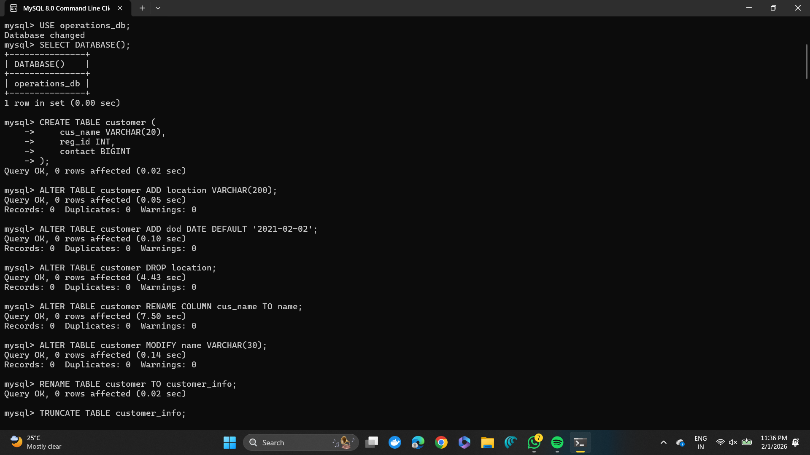

- DDL Constrains: 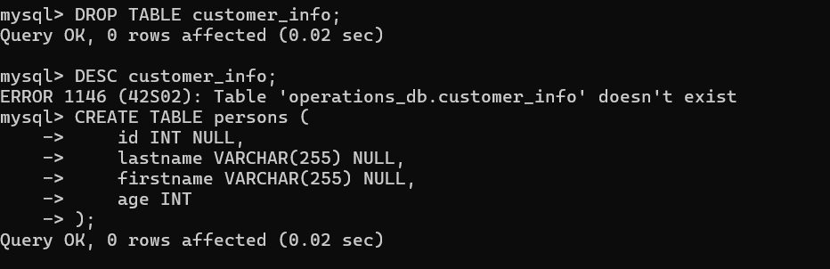

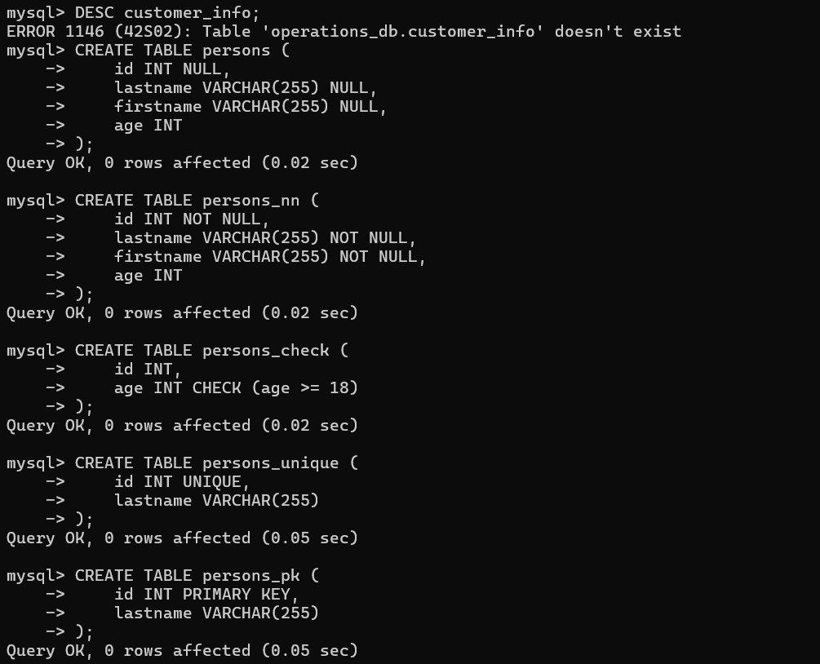

- DML Queries:

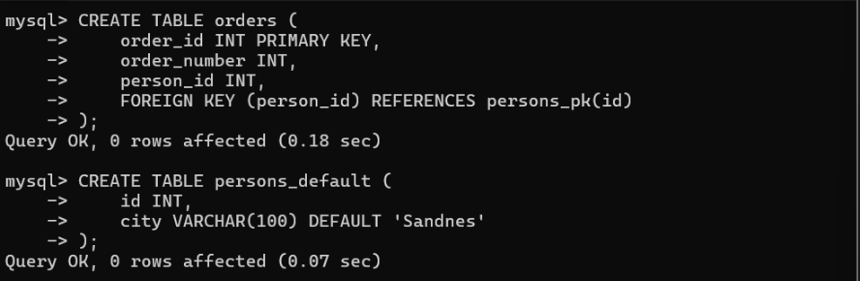
.

TASK-2
DML QUERIES AND WITH AGGREGATION FUNCTION, CLAUSE AND NESTED QUERIES

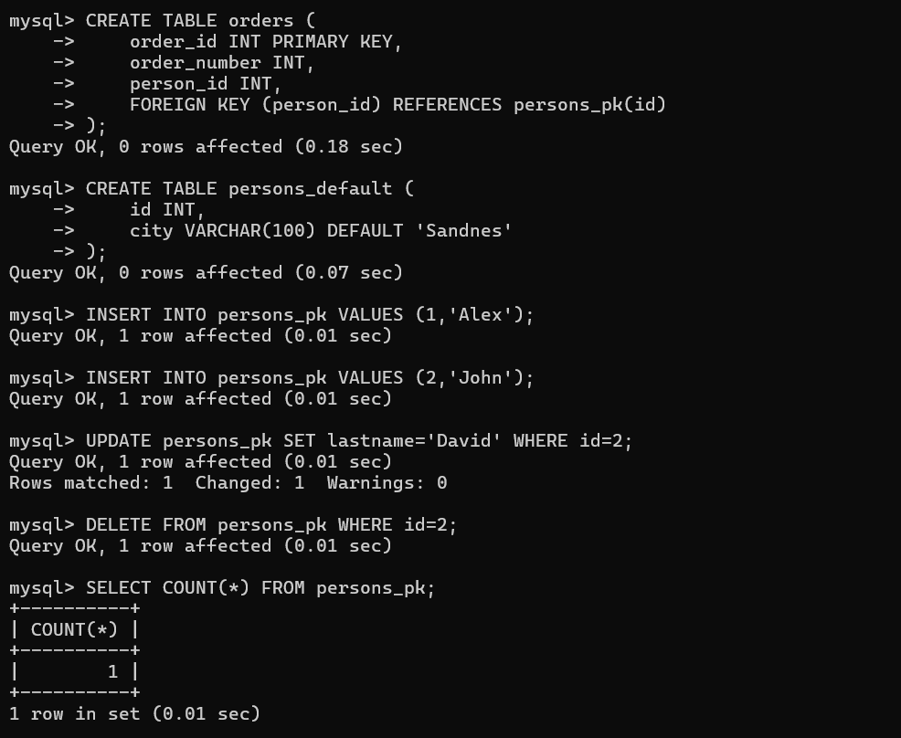
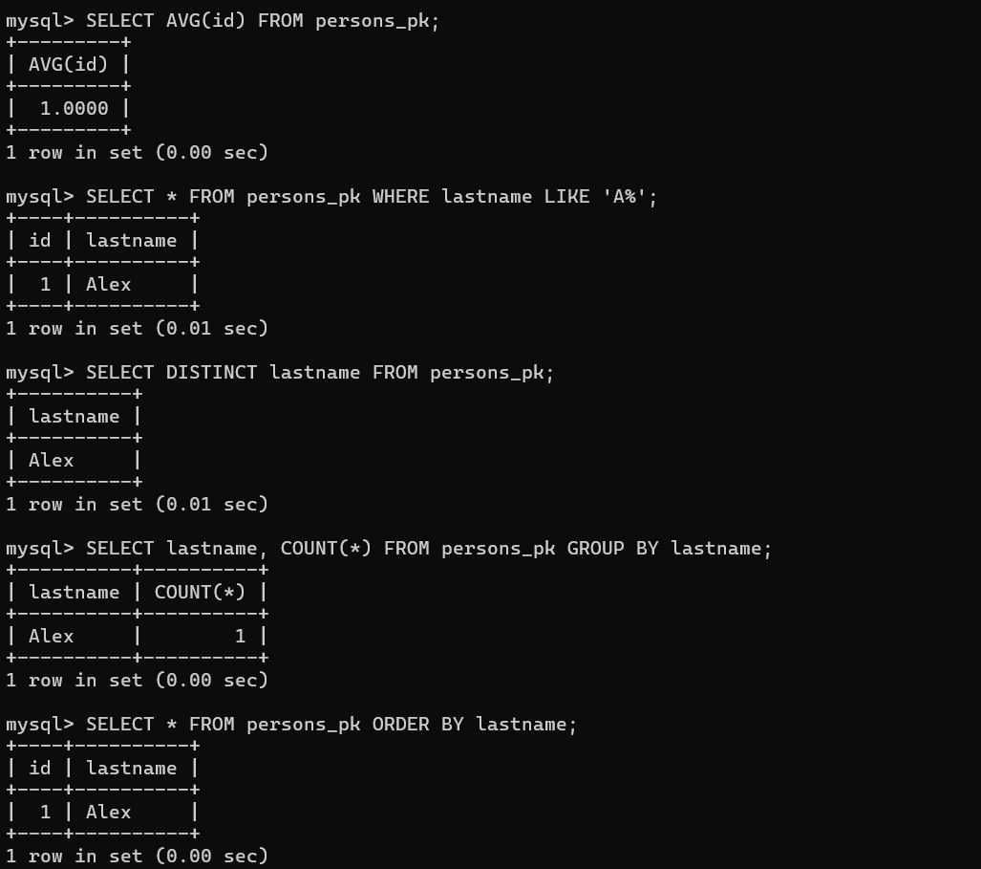

TASK-3
Joins and Set operations
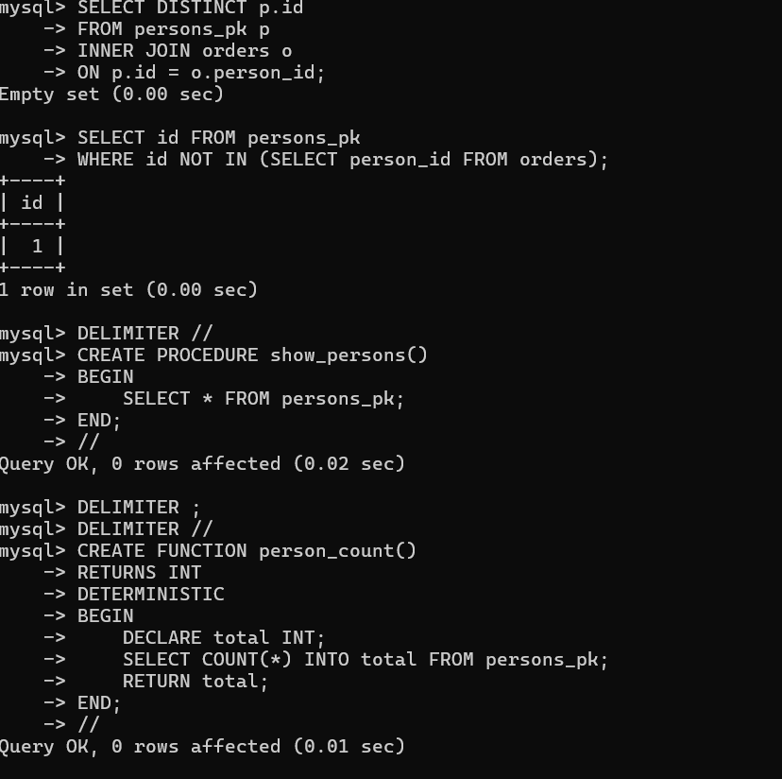
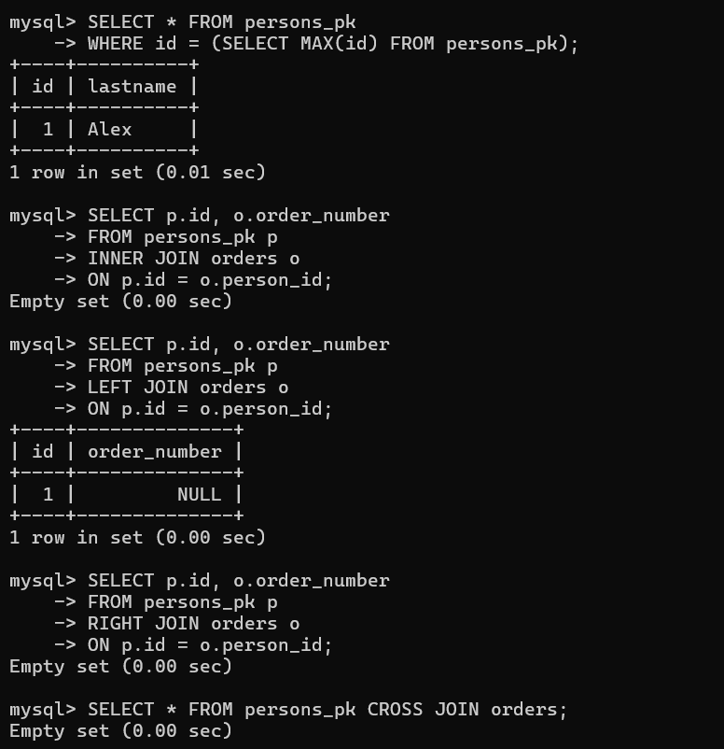
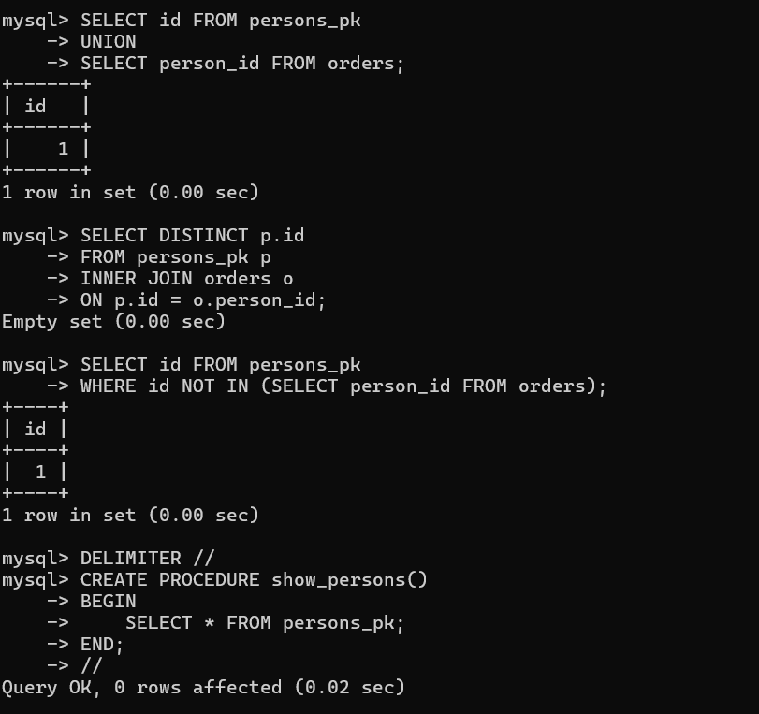

Task -4
PL/SQL Procedures, functions, Loops

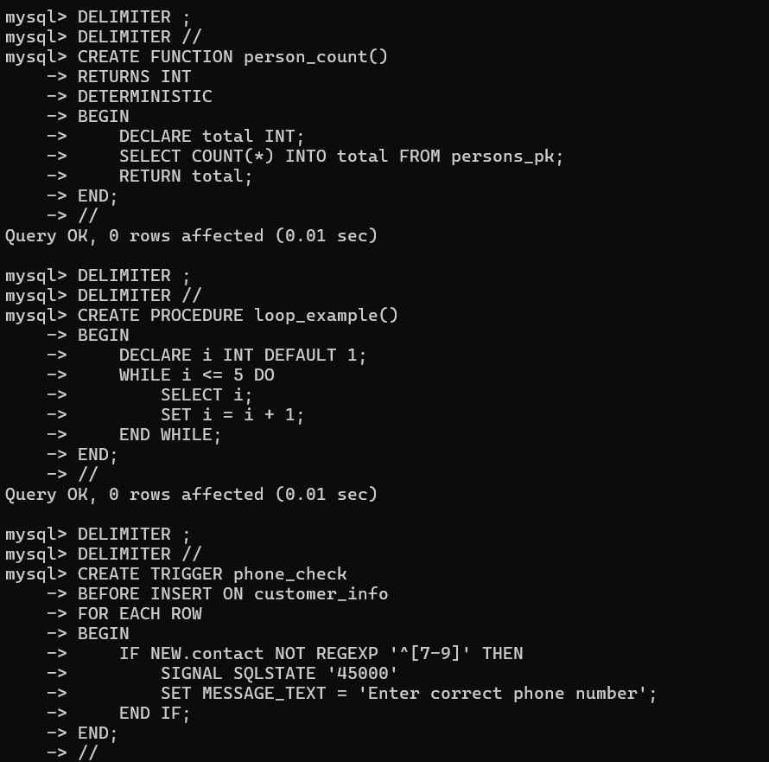
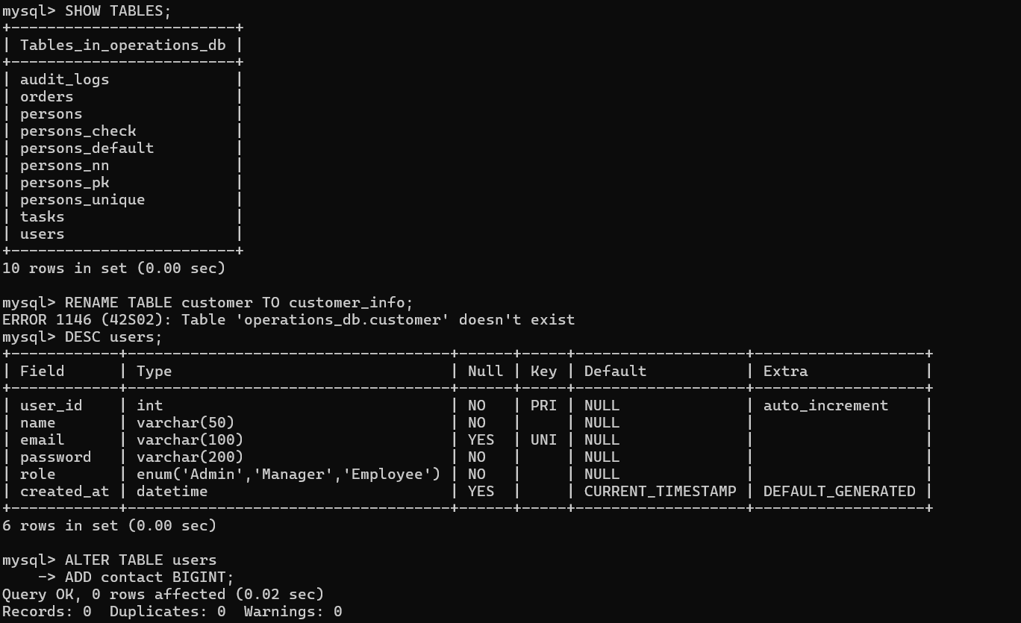

Task 05
TRIGGER, VIEW & EXCEPTION

